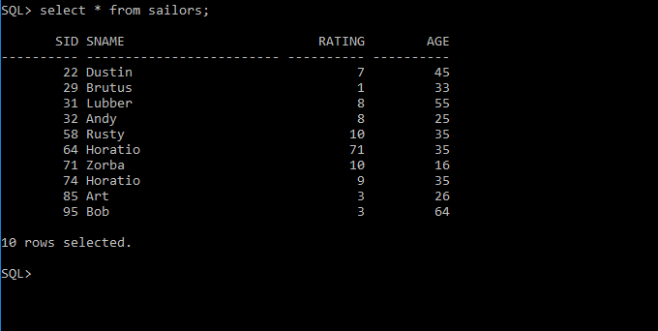

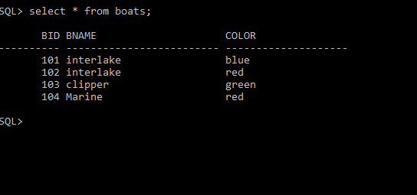

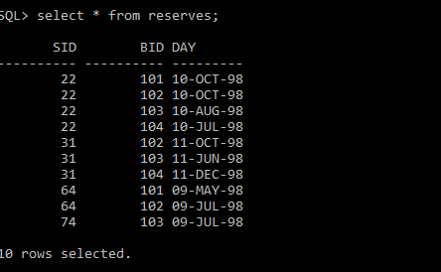

1 Find the names and ages of all sailors

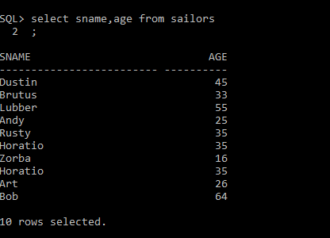

2 Find all information of sailors who have reserved boat number 101.

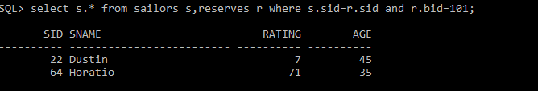

3 Find all sailors with rating above 7

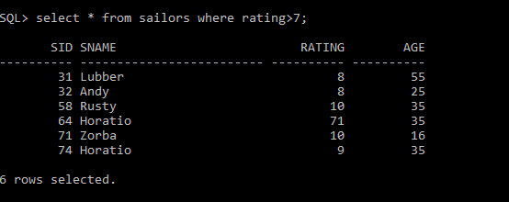

4 Find the names of sailors who have reserved boat no 103



5 Find the names of sailors who have reserved a red boat, and list in the order of age.

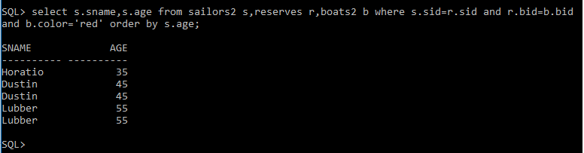

6 Find the names of sailors who have reserved either a red or green boat

select s.sname from sailors s,reserves r,boats b where s.sid=r.sid and b.bid=r.bid and b.color='red' or b.color='green';

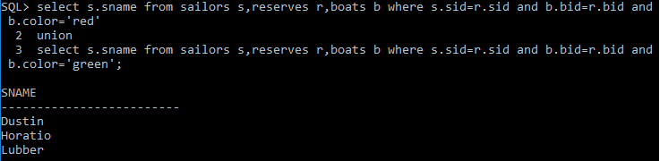

7 Find the colors of boats reserved by “Lubber”.

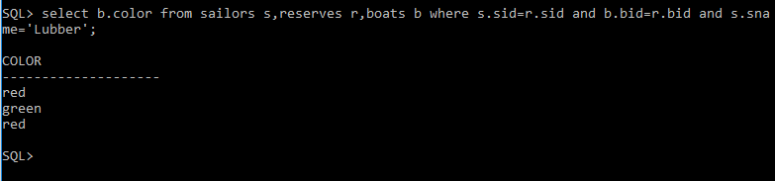

8.Find the names of sailors who have reserved both red and green boats

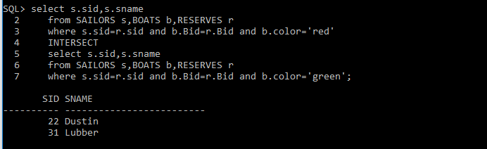

9. Find the names of sailors who have reserved at least one boat

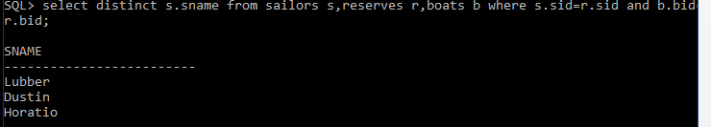

or

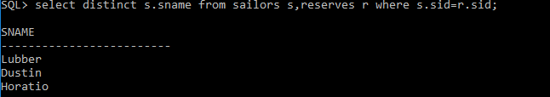

or

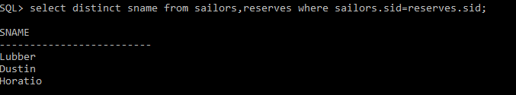

10.Find the ids and names of sailors who have reserved two different boats on the same day.

11.Find the name and the age of the youngest sailor.



12.Find the names and ratings of a sailor whose rating is better than some sailor called Horatio.

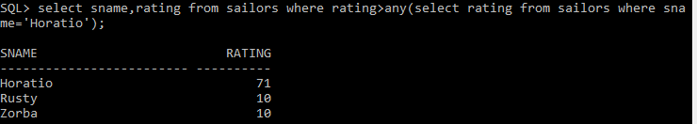

13.